# Programming Talaria TWO EVB

Flash the ELF using the Download Tool:

1. Launch the Download tool provided with InnoPhase Talaria TWO SDK.
2. In the GUI window:
   1. Boot Target: Select the appropriate EVK from the drop-down.
   2. ELF Input: Load the appropriate ELF by clicking on Select ELF File.
   3. AP Options: Provide the appropriate SSID and Passphrase of the Access Point.
   4. Programming: Click on PROG Flash.

**Note**:

1. To flash the application over the JTAG/SWD, refer Programming_using_INP3000

Ensure that the output is as shown in Figure 22. If not, Click on Clear Flash on the Download Tool and program the ELF onto Talaria TWO again.

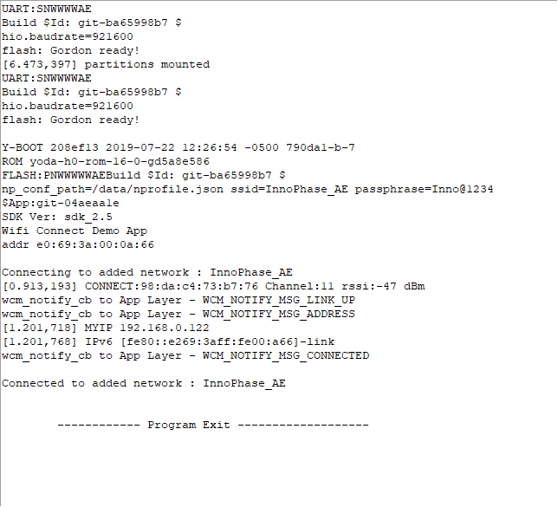

Figure 22: Programming the ELF - Download Tool console output